**Amaris One:**

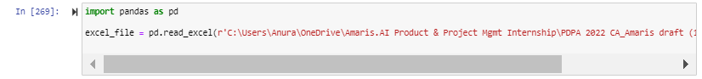

**Copy Question Explanation Column To QuestGen.AI Column:**

**Updated Amaris PDPA Excel Testing Sheet:**

**Boolean (Yes/No) Question Generator From QuestGen.AI Column Using NLP QuestGenAI Question Generator:**

114 cell is blank which will result in errors and that’s why length I put as 114 (to print out 113 rows)

**Updated Amaris PDPA Testing Excel Sheet With Additional Column On Boolean (Yes/No) Question Generated From Repository:**

**Amaris One:**



**Copy Question Explanation Column To QuestGen.AI Column:**

**Updated Amaris PDPA Excel Testing Sheet:**

**MCQ Questions Generator From QuestGen.AI Column Using NLP QuestGenAI Question Generator:**

**Updated Amaris PDPA Testing Excel Sheet With Additional Column On MCQ Questions Generated From Repository:**

**Amaris One:**



**Copy Question Explanation Column To QuestGen.AI Column:**

**Updated Amaris PDPA Excel Testing Sheet:**

**FAQ Generator From QuestGen.AI Column Using NLP QuestGenAI Question Generator:**

**Updated Amaris PDPA Testing Excel Sheet With Additional Column On MCQ Questions Generated From Repository:**

Insert Amaris ones below…

Insert Amaris one below…

Insert Amaris one below…